**DAILY ONLINE ACTIVITIES SUMMARY**

|  |  |  |  |  |  |  |  |  |
| --- | --- | --- | --- | --- | --- | --- | --- | --- |
| **Date:** | **27-05-2020** | | | | | **Name:** | **RACHANA K N** | |
| **Sem & Sec** | **VI B** | | | | | **USN:** | **4AL17CS070** | |
| **Online Test Summary** | | | | | | | | |
| **Subject** | | **SSCD TEST-2** | | | | | | |
| **Max. Marks** | | **30** | | **Score** | | | **18** | |
| **Certification Course Summary** | | | | | | | | |
| **Course** | **Machine Learning With Python** | | | | | | | |
| **Certificate Provider** | | | **IBM** | | **Duration** | | | **10HR(course completed)** |
| **Coding Challenges** | | | | | | | | |
| **Problem Statement:1 problem** | | | | | | | | |
| **Status: solved** | | | | | | | | |
| **Uploaded the report in Github** | | | | | **yes** | | | |
| **If yes Repository name** | | | | | DAILY_STATUS | | | |
| **Uploaded the report in slack** | | | | | **yes** | | | |

Online test details

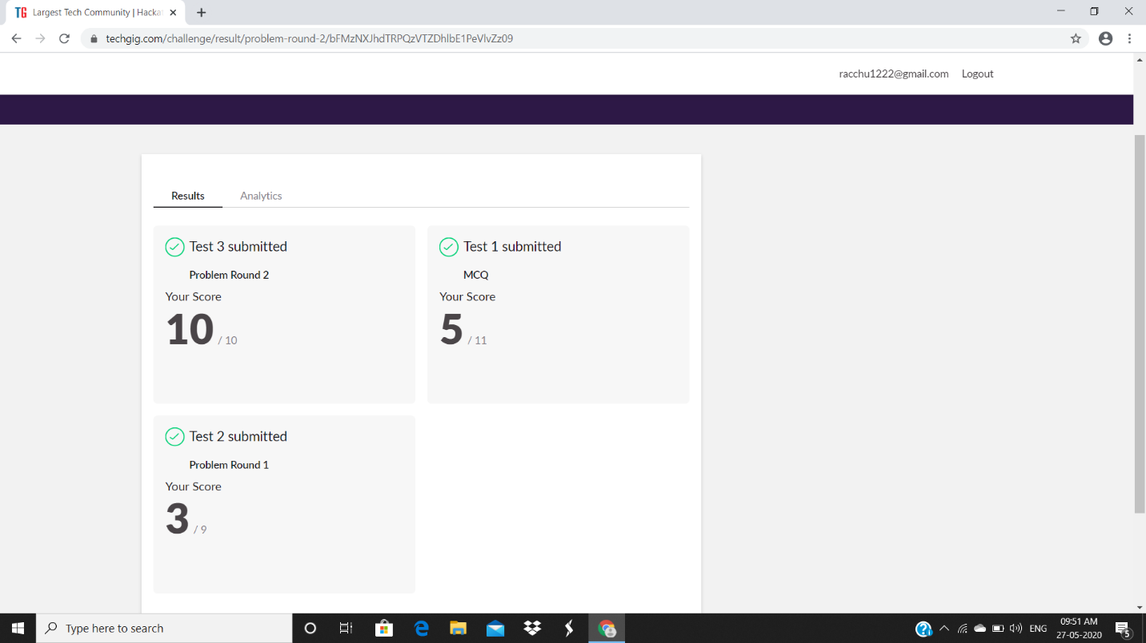

**Coding challenges and details:**

Github link for detail information: https://github.com/rachnarayan1201/daily_status_coding/commits?author=rachnarayan1201

Solved and uploaded in github